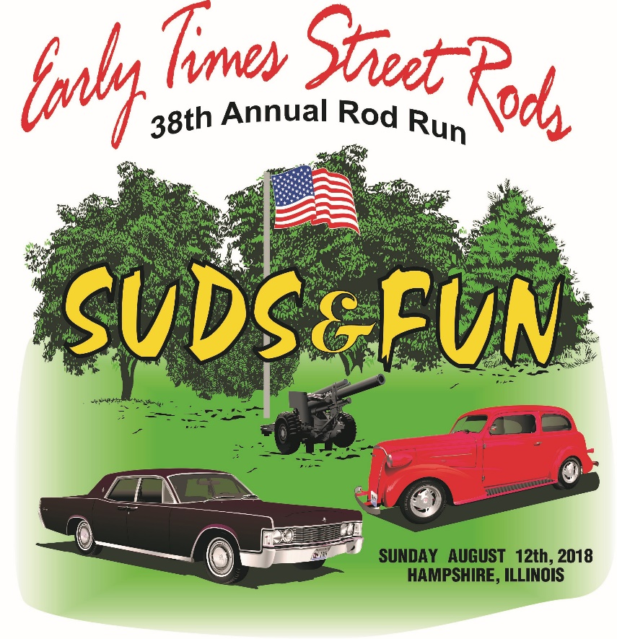

Sunday, August 12, 2018 Open Car Show: Entry $ 18.00
Hampshire, IL (400 East Jefferson St.) Over 600 cars at past shows
Registration: 8am – Noon Suds & Fun Beer tent
Awards: 2:30 pm Food Tent
CONTACT: Don 847-727-3006 Door prizes and 50/50 raffle
Linda 708-278-6944 More Trophies and Food Wagon
Come join us in our beautiful park for a car show that is laid back, with a picnic like atmosphere. This show is not judged by classes, but for fun, our staff awards a Best of the Brew plaque to several lucky cars. This is Northern Illinois largest and longest running car show held by a single home town car club. Hope to see you there! ……..Early Times Street Rods. To print a registration form go to SUDSANDFUN.COM

Event T-shirts to all pre-entries post marked before July 6th
No pre-entries will be mailed: you must arrange pick-up if not present
All pre-entries must include full payment and this completed registration form
(Detach here)

Name: ____________________________________________ E-mail _____________________________________

Address: _____________________________________________________City: ______________________

State: _______ Zip: _______________ Phone: __________________________ Car ____________________________

T-shirt size (circle one) S M L XL XXL XXXL

Notice – No trailers, scooters, golf carts, etc. allowed unless authorized by Early Times Street Rods.
Liability: In consideration of the acceptance of the right to participate, entrants, by the signing of this form, release and discharge Early Times Street Rods of Northern Illinois, Inc. and their officers, members and anyone else connected with the presentation of this year’s Suds & Fun event of and from any claim from any cause whatsoever that may be suffered by an entrant, or family member,; to their person or property. I have read and agree to all conditions.

_________________________________________________ _________________________________________
Entrant’s signature Guardian if entrant is under 18

MAIL TO: Early Times Street Rods P.O. Box 312 Hampshire, IL 60140

